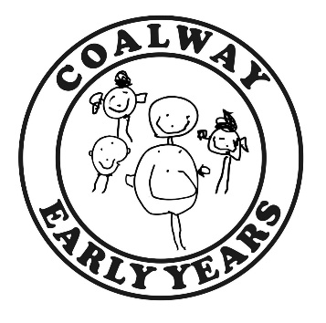

Dear Parent/Carer,

As part of our ongoing planning, observation and assessment systems we use an on-line learning journal via ‘Parenta’. In this journal we complete observations using photographs, videos and narrative to demonstrate the teaching we are providing and to keep you informed about your child’s learning and development. We also use this tool to complete assessments, track progress and produce reports.

Parents is a safe and secure database which can only be accessed by the staff of ‘Coalway Early Years’ and family members authorised by us, with your consent.

In order to set up this system for your child we need you to complete and return the attached slip. Once we have this information we will send you a link to the email address(es) provided – the account needs to be activated within 24 hours of receipt of this email. Follow the simple links to create login details (password and PIN) and you can then access your child’s learning journal through

https://parentportal.parenta.com/login/303812

or download the App (see App store) onto any smartphone or tablet.

There is also a video for you to watch that will help you to navigate the new app and tell you more information on how to use the app. The link for this is below

https://www.youtube.com/watch?v=w1B8k1mDf5A

It is important to note that your child may sometimes appear in photographs or videos on other children’s learning journals. This is because we often use group activities to demonstrate and assess learning. Your child’s name will never be used in the narrative attached to these observations.

We ask that you log in regularly to Parenta to view your child’s journal and provide feedback by commenting and sharing information and pictures from home!. Your involvement and input is vital to your child’s development and in order for us to accurately access their progress and learning needs. Periodically, we make summative assessments using Parenta and will share these with you. When your child leaves ‘Coalway Early Years’ we will complete a transition report on Parenta to share with you and your child’s school or next setting, and you will have the option to purchase your child’s learning journal for a small administration fee on a USB stick so that you can keep the memories forever!

NB: ‘Coalway Early Years’ prohibits the sharing of any photographs, videos or narrative from Parenta via social media or any other means.

Please complete the slip attached and return. If we can be any help, or if you have any questions please do not hesitate to contact us.

Kind Regards,
Kayleigh Hoskings
Manager

Parenta Learning Journal - Permission Slip

Child’s Full Name:

Child’s Date of Birth (DD/MM/YYYY):

Please complete details below to allow us to create an account for you.

Name…………………………………………………………………………………………………………………………………………………………………………………
Email………………………………………………………………………………………………………………………………………………………………………………….
Relationship to child……………………………………………………………………………………………………………………………………………………….

Name………………………………………………………………………………………………………………………………………………………………………………….
Email…………………………………………………………………………………………………………………………………………………………………………………..
Relationship to child………………………………………………………………………………………………………………………………………………………..

I give my permission for Coalway Early Years to create a Parenta Learning Journal for my child. I authorise Coalway Early Years to send login links to the email addresses listed above.

Signed: …………………………………………………………………………..

Name: ……………………………………………………………………………..

Date:………………………………………………

